QUESTION 2
Weather Report Filesystem & GitHub Repository
Implementation and Verification Report

1. Assignment Requirements
Provision a dedicated approximately 10 GB weather_report filesystem on the Ubuntu server. Create and configure an upstream repository for the weather report project and clone it inside the mounted filesystem. The example repository name weather_report_nelson was replaced with weather_report_kuye; GitHub was used instead of GitLab.

2. Environment
Server | Ubuntu host: automation
Linux user | segun
Disk / partition | /dev/sdb / /dev/sdb1
Mount point | /weather_report
Filesystem | ext4
GitHub repository | segun-jpg/weather_report_kuye
Local repository | /weather_report/weather_report_kuye
Branch | main

3. Implementation Narrative

Step 1 — Inspect disk capacity
Used lsblk and df -h to verify the dedicated disk and confirm the partition is mounted. The disk appeared as approximately 10.1 GB, and df -h reported about 9.9 GB filesystem capacity with approximately 9.3 GB available.
lsblk
df -h

Step 2 — Verify the mount and directory
Navigated to the weather_report mount and listed its contents. The project directory weather_report_kuye already existed and was owned by user segun.
cd /weather_report
pwd
ls -la

Step 3 — Verify GitHub upstream
Entered the existing local repository and checked the configured remote. Both fetch and push point to the intended GitHub repository. Because the repository was already present, no second clone was necessary.
cd /weather_report/weather_report_kuye
git remote -v
git remote get-url origin

Step 4 — Verify Git status and branches
Checked the local main branch and its tracking branch origin/main. Git reported that the branch was up to date and the working tree was clean.
git status
git branch -a

Step 5 — Verify filesystem type and mount
Ran findmnt to confirm that /dev/sdb1 is mounted at /weather_report as an ext4 filesystem with read-write access.
findmnt /weather_report

4. Verified Evidence
The PuTTY output confirmed:
- Mount: /weather_report /dev/sdb1 ext4 rw,relatime
- Git remote: https://github.com/segun-jpg/weather_report_kuye.git
- On branch main; up to date with origin/main
- Nothing to commit; working tree clean
Screenshot evidence: final PuTTY terminal verification (findmnt, git remote, git status, git branch).
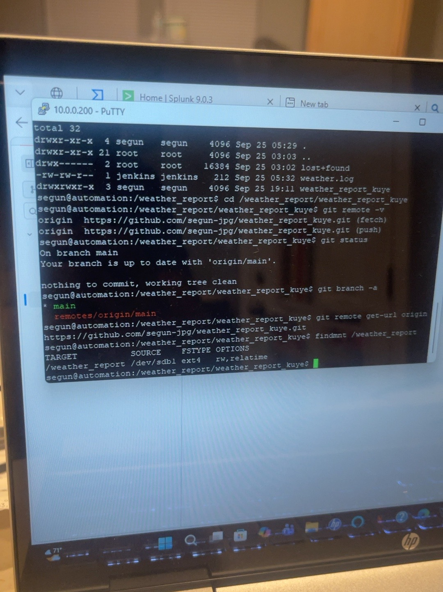

5. Conclusion
The Ubuntu server has a dedicated ext4 filesystem mounted at /weather_report, and the weather_report_kuye project is present inside it with a configured GitHub upstream. The main branch tracks origin/main and was clean at the time of verification. These checks demonstrate the requested filesystem and repository configuration. Application hosting or a running weather-report service was not independently verified in these screenshots.

